Urban Taxi Trajectory Analysis and Trip Duration Prediction
Using the T-Drive Dataset
Data Science and Algorithms Group Project Report
Course | Data Science and Algorithms
Dataset | T-Drive taxi trajectory data
Study Period | 2 Feb 2008 to 8 Feb 2008
Prepared By | Group members: Nicole Lee En Xin 1820232039, Too Lucas Weichen 1820232051, Liew Zhan Wang 1820232038, Naiya Regina 1820232053, Sim Kai Lin 1820232059

Abstract
This report presents an urban mobility study based on the T-Drive dataset, a large-scale GPS trajectory dataset of Beijing taxis. The project aims to discover temporal and spatial travel patterns and to evaluate whether trip duration can be predicted from simple trajectory-derived features. After preprocessing 17,662,984 raw GPS records from 10,336 taxis, the pipeline retained 16,082,407 clean points and extracted 112,538 trips. Exploratory analysis shows a dense spatial concentration in central Beijing, clear intra-day variation, and a higher number of weekday trips than weekend trips. The extracted trips have an average distance of 94.78 km and an average duration of 475.48 minutes, although both variables are strongly right-skewed. For trip duration prediction, Linear Regression was used as a baseline and Random Forest was used as a non-linear model. Random Forest achieved the best performance with MAE = 110.63, RMSE = 311.78, and R² = 0.9154, substantially outperforming Linear Regression. The results indicate that urban taxi trajectories contain meaningful mobility structure and that machine learning can model trip duration with high accuracy, while extreme long-duration trips remain challenging.

1. Introduction
Taxi trajectory data provides a detailed view of how people and vehicles move through a city. Compared with aggregate traffic counts, GPS trajectories preserve spatial detail and time order, making them useful for studying mobility patterns, hotspot regions, and route behavior. Such analysis is valuable for traffic planning, congestion management, and smart-city applications.
This project focuses on the T-Drive dataset, which contains GPS trajectories of 10,357 taxis in Beijing between 2 February and 8 February 2008. According to the official user guide, the dataset contains about 15 million GPS points and each file is named by taxi ID, with each row storing taxi id, date time, longitude, and latitude. The average sampling interval is about 177 seconds and the average distance between consecutive points is about 623 meters.
The goals of this project are twofold. First, we analyze the temporal and spatial distribution of taxi movements in Beijing. Second, we construct trip-level features and use them to predict trip duration. The report follows the complete data science workflow required by the course: problem definition, data collection and processing, exploratory analysis, visualization, modeling, and quantitative evaluation.

2. Research Questions and Objectives
- What temporal patterns can be observed in taxi trips over the day?
- How are GPS points distributed spatially across Beijing, and where are the hotspot regions?
- How do weekday and weekend trip volumes differ?
- What are the statistical characteristics of trip distance and trip duration?
- Can trip duration be accurately predicted using trajectory-derived features?

3. Dataset Description and Preprocessing
The raw dataset used in this project contains 17,662,984 GPS records from 10,336 taxis. Each trajectory file corresponds to one taxi. The raw files were read as comma-separated text and converted into a unified table containing taxi ID, timestamp, longitude, and latitude.

3.1 Preprocessing Pipeline
The preprocessing stage was designed to reduce noise while preserving realistic mobility information. The main operations were as follows: (1) parse all text files and convert timestamps to datetime format; (2) remove missing values; (3) discard records with coordinates outside the valid geographic bounds of Beijing; (4) remove duplicate records; (5) remove physically implausible observations identified through excessively high inferred speed; and (6) sort records by taxi and time before trajectory segmentation.
Stage | Rows Remaining | Change from Previous Stage
Raw records | 17,662,984 | —
After dropna | 17,662,984 | +0
After coordinate bounds filtering | 17,484,530 | -178,454
After de-duplication | 16,160,617 | -1,323,913
After removing too-fast rows | 16,082,407 | -78,210
In total, 1,580,577 records (8.95%) were removed during cleaning. The largest reduction came from duplicate records (1,323,913 rows), indicating that repeated GPS points are common in the raw files.

3.2 Trip Extraction
After point-level cleaning, trips were segmented from ordered trajectories using time-gap based rules. Consecutive points were grouped into the same trip unless the temporal gap exceeded the preset threshold, in which case a new trip was started. For each extracted trip, the following features were computed: start time, end time, start and end coordinates, duration, total distance, number of GPS points, average speed, start hour, weekday, and weekend indicator.
This process yielded 112,538 trips. The average trip distance is 94.78 km and the average trip duration is 475.48 minutes. However, the averages are strongly influenced by long-tail trips, so medians and distribution plots are also discussed in the next section.

4. Exploratory Data Analysis

4.1 Spatial Distribution of GPS Points
Figure 1 plots the cleaned GPS points. The distribution forms a dense central cluster around the urban core of Beijing, with several radial extensions toward surrounding districts. This pattern is consistent with city-center concentration of taxi demand. The densest hotspot cells in the grid are located around longitude 116.36-116.46 and latitude 39.90-39.96, confirming that the most intensive taxi activity is concentrated in central Beijing.
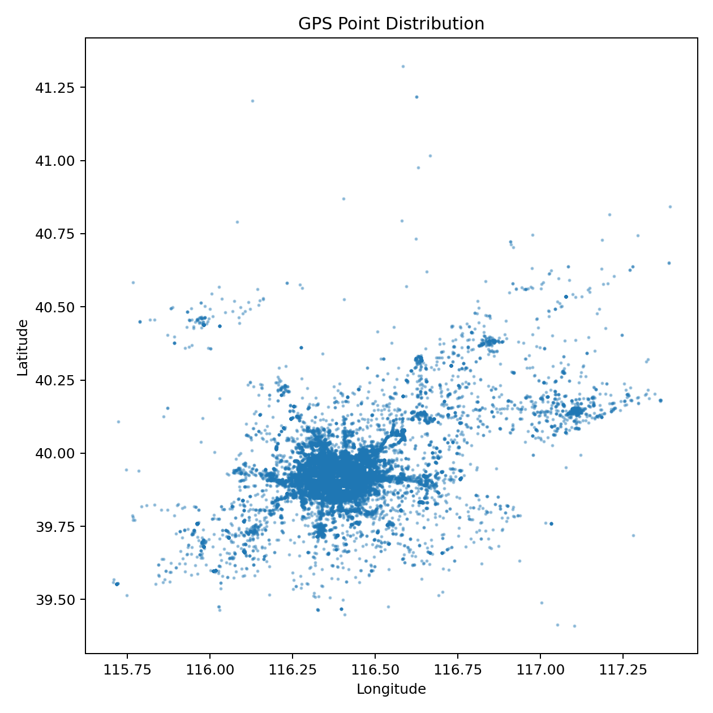
Figure 1. Spatial distribution of cleaned GPS points.
Table 1 reports the top five hotspot grid cells extracted from the spatial aggregation.
Grid longitude | Grid latitude | Point count
116.42 | 39.90 | 286,548
116.42 | 39.94 | 230,261
116.36 | 39.90 | 210,587
116.46 | 39.92 | 204,066
116.46 | 39.90 | 198,723

4.2 Temporal Trip Patterns
Figure 2 shows clear hourly variation in trip activity. The number of trips begins to rise after 07:00, reaches a strong morning level around 09:00-11:00, and peaks at 13:00 with 12,405 trips. Trip volume remains relatively high through the afternoon before declining in the evening. The five busiest hours are 13:00 (12,405 trips), 9:00 (7,401 trips), 10:00 (7,359 trips), 11:00 (7,049 trips), 15:00 (6,734 trips). The low counts in the early morning indicate reduced taxi activity overnight.
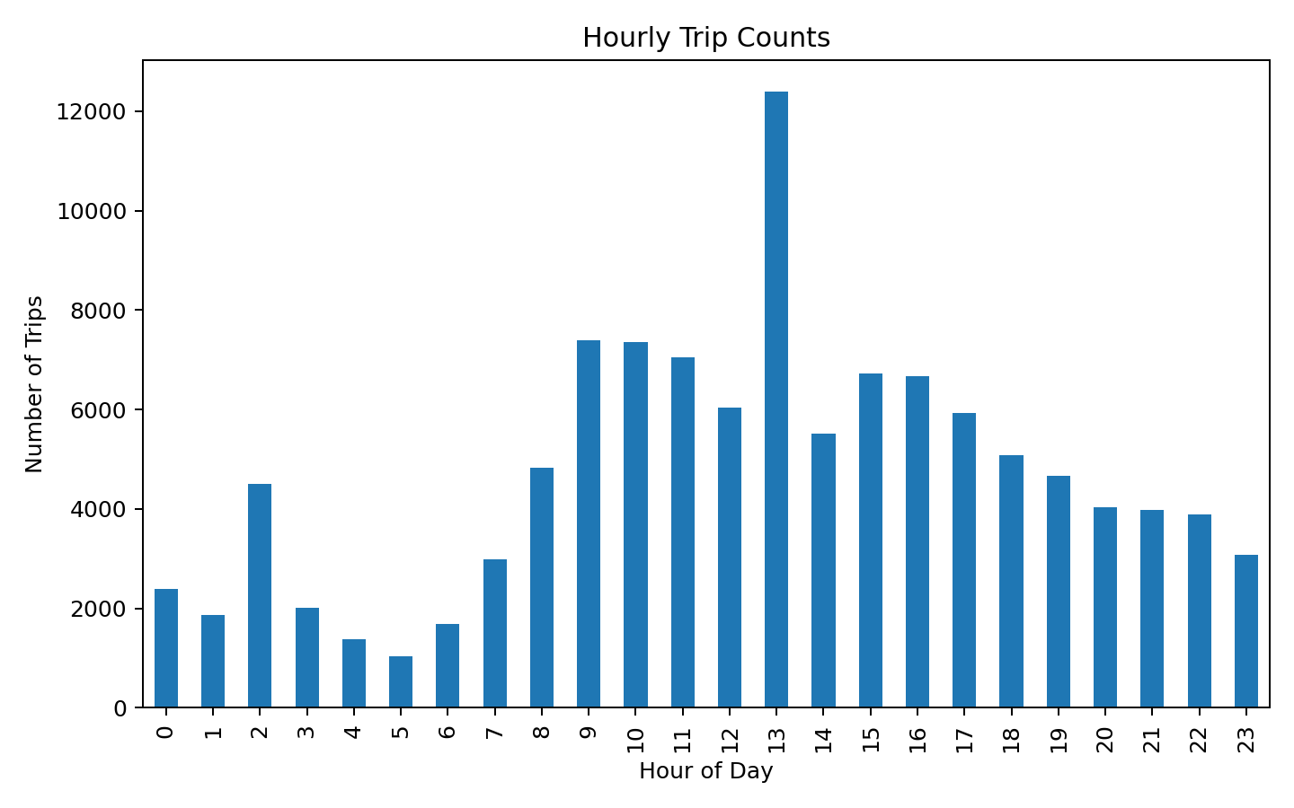
Figure 2. Hourly distribution of extracted trips.
Figure 3 compares weekday and weekend trip totals.
Weekdays account for 77,323 trips, while weekends account for 35,215 trips. This means weekday trips are about 2.20 times as many as weekend trips in the extracted sample. The result suggests that work-related and routine commuting activities contribute strongly to overall taxi usage.
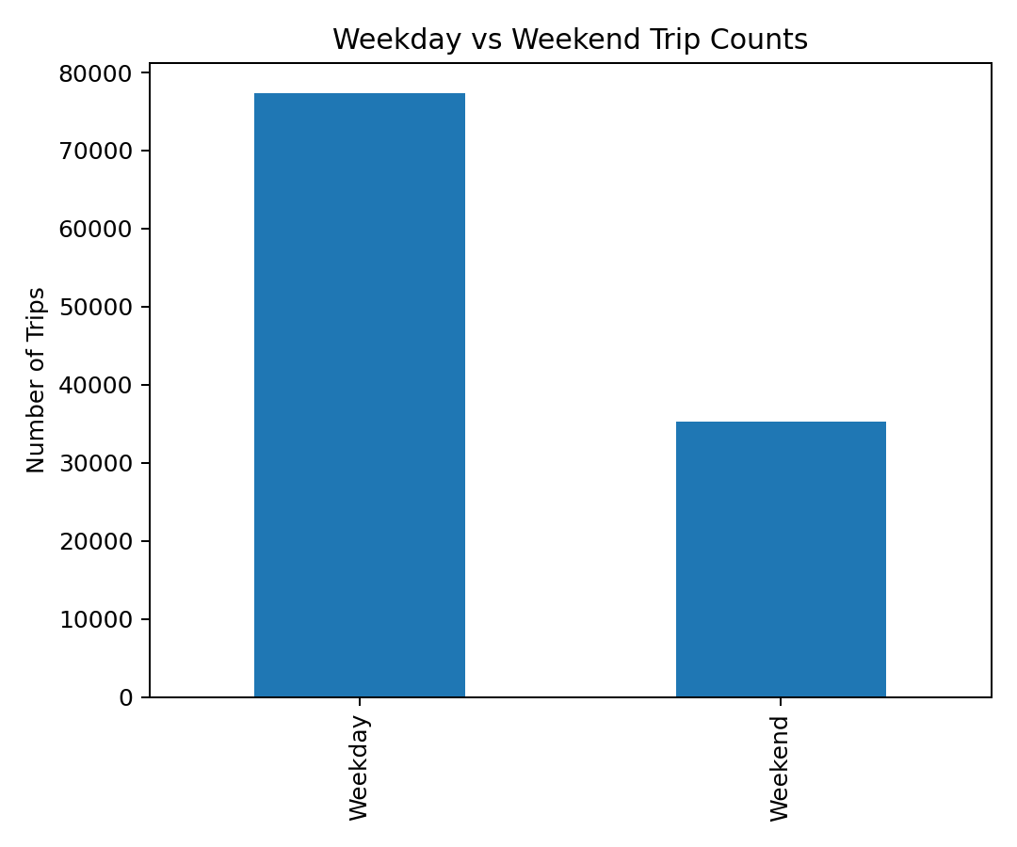
Figure 3. Weekday versus weekend trip counts.

4.3 Trip Distance and Trip Duration Distributions
Figures 4 and 5 show the empirical distributions of trip distance and trip duration. Both are strongly right-skewed. The median trip distance is 47.39 km, while the mean is 94.78 km. For trip duration, the median is 153.88 minutes and the mean is 475.48 minutes. The large gap between median and mean indicates the presence of a substantial long tail. At the 95th percentile, trip distance reaches 328.39 km and trip duration reaches 2158.29 minutes. A small number of extremely long observations remain even after cleaning, which is visible in the far-right tails.
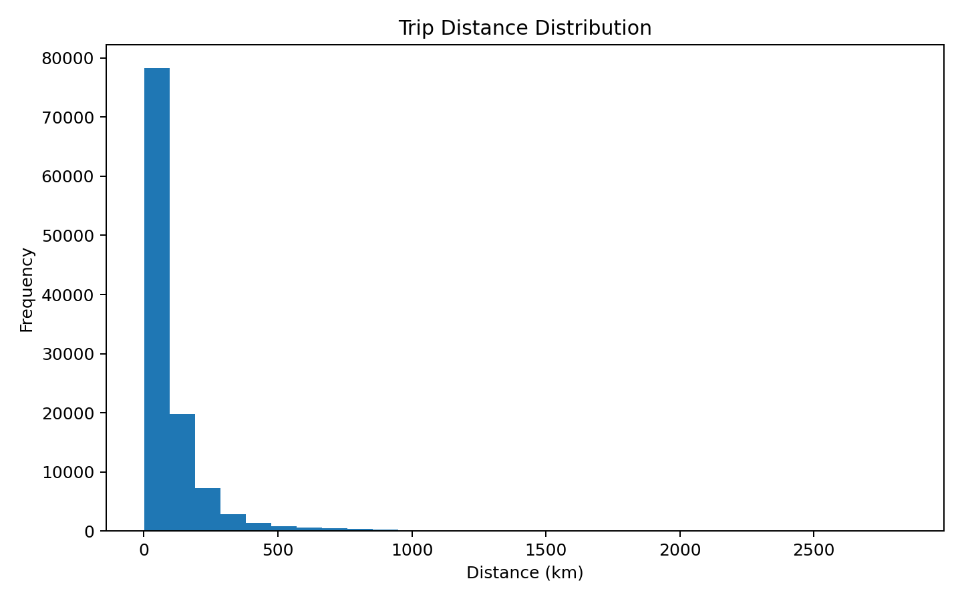
Figure 4. Distribution of trip distance.
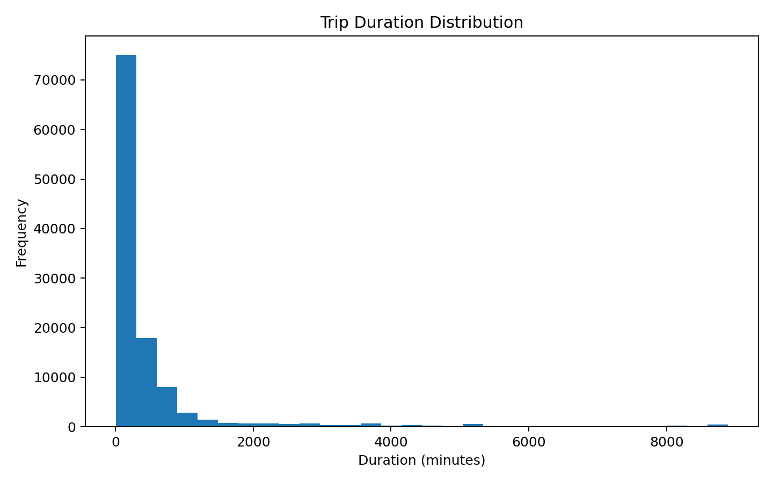
Figure 5. Distribution of trip duration.

5. Modeling Methodology
The supervised learning task in this project is trip duration prediction. Each extracted trip is treated as one sample, and the target variable is duration in minutes. The input features include trip distance, number of GPS points, start hour, start weekday, and weekend indicator. These features were chosen because they are easy to derive from trajectories and they capture both spatial scale and temporal context.

5.1 Models
Two regression models were evaluated. Linear Regression was used as a simple baseline to test whether a basic linear relationship can explain trip duration. Random Forest Regressor was selected as the main non-linear model because it can capture interactions and non-linear effects without requiring heavy feature engineering.

5.2 Evaluation Metrics
Model performance was assessed using Mean Absolute Error (MAE), Root Mean Squared Error (RMSE), and the coefficient of determination (R²). Lower MAE and RMSE indicate better prediction accuracy, while a higher R² indicates that the model explains more variance in trip duration.

6. Prediction Results
Table 2 compares the quantitative performance of the two models. Random Forest substantially outperforms Linear Regression on all three metrics.
Model | MAE | RMSE | R²
Linear Regression | 271.17 | 610.96 | 0.6750
Random Forest | 110.63 | 311.78 | 0.9154
Linear Regression achieved MAE = 271.17, RMSE = 610.96, and R² = 0.6750. Random Forest improved these results to MAE = 110.63, RMSE = 311.78, and R² = 0.9154. In relative terms, Random Forest reduced MAE by 59.20% and RMSE by 48.97% over the baseline.
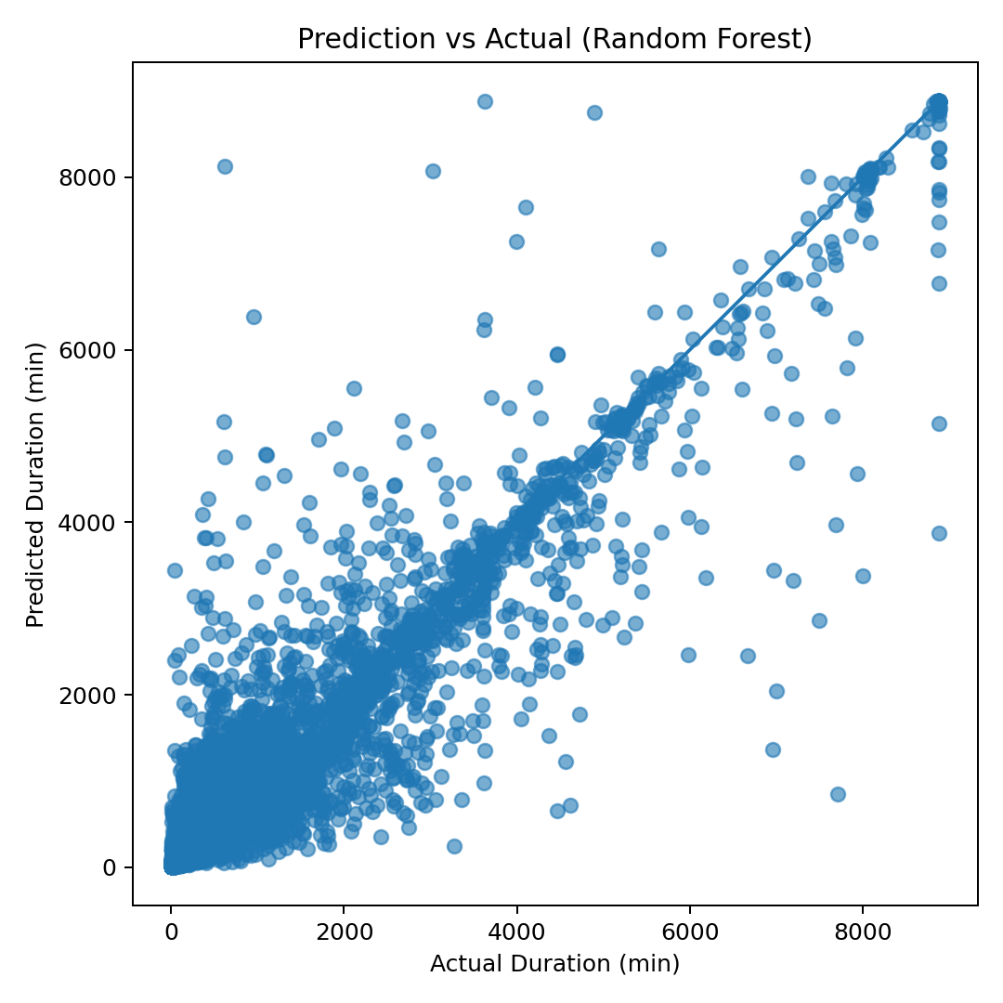
Figure 6. Predicted versus actual trip duration for the Random Forest model.
Figure 6 shows that most predictions from Random Forest lie close to the diagonal trend line, especially for short and medium trips. Prediction error becomes more visible for very long trips, where the data are sparse and more variable. This behavior is common in trajectory prediction problems because extreme trips may reflect unusual routes, prolonged waiting, or noisy segmentation.

7. Discussion
The analysis reveals three main findings. First, taxi GPS activity is strongly concentrated in the urban core of Beijing, which indicates that central districts dominate taxi usage. Second, trip demand varies clearly over time, with the highest activity from late morning to afternoon and noticeably lower activity overnight. Third, weekday trip volume is significantly higher than weekend trip volume, suggesting that regular workday mobility has an important effect on taxi demand.
From the modeling perspective, the strong performance of Random Forest shows that trip duration depends on non-linear relationships among trajectory-derived features. Distance is naturally one of the most informative variables, but temporal variables such as hour and weekday also improve prediction because urban traffic conditions differ across time periods.
At the same time, the descriptive statistics indicate that the extracted trip set still contains very long trajectories. This explains why the mean distance and duration are much larger than the medians and why the histograms display heavy right tails. These long observations may represent genuine long-distance trips, but they may also include trips affected by idle periods, complex driver behavior, or segmentation limitations. Therefore, the prediction results should be interpreted together with the distributional evidence rather than relying only on average values.

8. Limitations and Future Work
This study has several limitations. First, the trip segmentation rule is based mainly on temporal gaps, so some parking periods or multi-stage trips may remain merged. Second, only a small set of features was used for prediction. External variables such as weather, holiday information, road network context, and region-based origin-destination features could improve model quality further. Third, the evaluation is performed on extracted trips rather than official trip labels, so the quality of segmentation directly affects all downstream analysis.
Future work can improve the project in several directions. More advanced trip extraction rules could be introduced using stop detection, speed thresholds, and spatial clustering. For prediction, gradient boosting, XGBoost, or sequence-based deep learning models could be compared with Random Forest. It would also be useful to connect the GPS coordinates to map regions and analyze origin-destination demand at the district level.

9. Conclusion
This project developed a complete data science workflow for the T-Drive dataset. Starting from 17,662,984 raw GPS points, the preprocessing pipeline produced 16,082,407 clean records and 112,538 extracted trips. Exploratory analysis identified strong spatial concentration in central Beijing, clear hourly variation in taxi activity, and a much larger number of weekday trips than weekend trips. The trip distance and duration distributions were found to be heavily right-skewed, highlighting the importance of robust interpretation beyond simple averages.
For the predictive task, Random Forest achieved the best result with R² = 0.9154, MAE = 110.63, and RMSE = 311.78, clearly outperforming Linear Regression. Overall, the project demonstrates that large-scale taxi trajectories are effective for discovering urban mobility patterns and for predicting trip duration using machine learning.

References
- J. Yuan, Y. Zheng, X. Xie, and G. Sun, "Driving with knowledge from the physical world," Proceedings of the 17th ACM SIGKDD International Conference on Knowledge Discovery and Data Mining, 2011.
- J. Yuan, Y. Zheng, C. Zhang, W. Xie, X. Xie, G. Sun, and Y. Huang, "T-drive: driving directions based on taxi trajectories," Proceedings of the 18th SIGSPATIAL International Conference on Advances in Geographic Information Systems, 2010.
- User Guide of T-Drive Data, Version 1.0, updated on August 12, 2011.
- Data Science and Algorithms course project requirement slides, Beijing Institute of Technology, 2026.

Appendix A. Key Numerical Summary
Indicator | Value
Raw GPS points | 17,662,984
Unique taxis | 10,336
Clean points | 16,082,407
Extracted trips | 112,538
Average trip distance (km) | 94.78
Median trip distance (km) | 47.39
Average trip duration (min) | 475.48
Median trip duration (min) | 153.88
Best model | Random Forest
Best model R² | 0.9154

